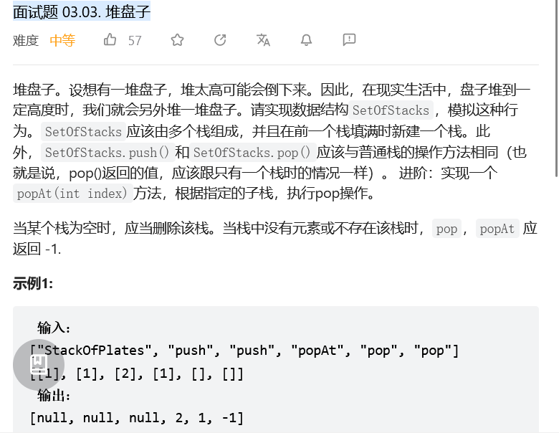
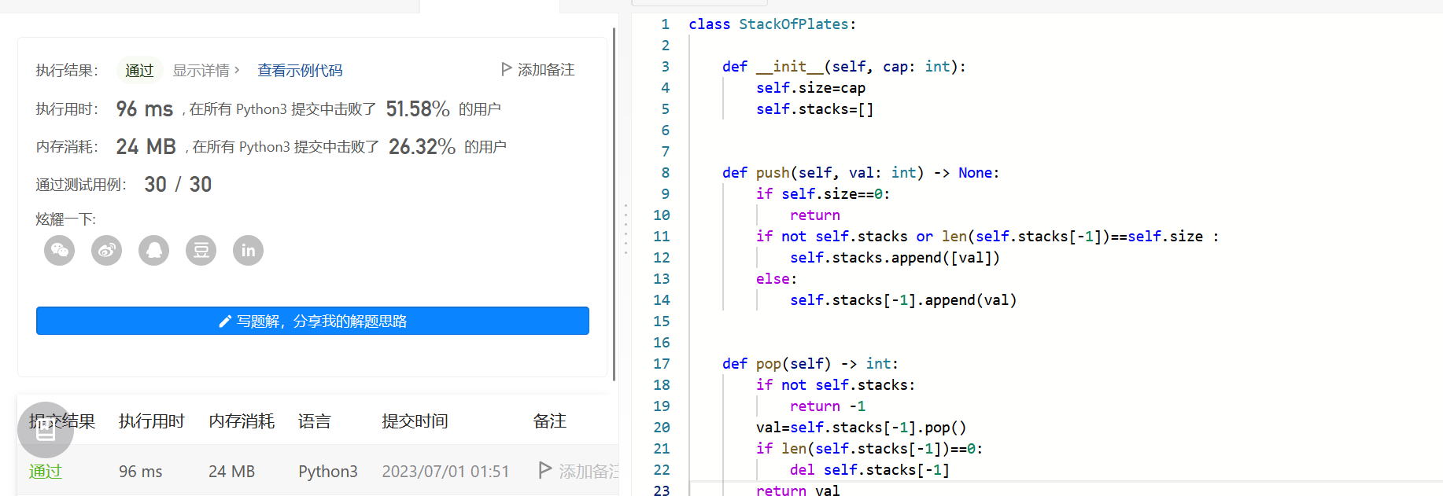
class StackOfPlates:

def __init__(self, cap: int):
self.cap = cap
self.array = []

def push(self, val: int) -> None:
# 处理边界情况：cap == 0 不让push
if self.cap == 0:
return

if not self.array or len(self.array[-1]) >= self.cap:
self.array.append([val])
else:
self.array[-1].append(val)

def pop(self) -> int:
val = -1
if self.array and self.array[-1]:
val = self.array[-1].pop()
if not self.array[-1]: self.array.pop()
return val

def popAt(self, index: int) -> int:
val = -1
if len(self.array) >= index + 1:
val = self.array[index].pop()
if not self.array[index]: self.array.pop(index)
return val

# Your StackOfPlates object will be instantiated and called as such:
# obj = StackOfPlates(cap)
# obj.push(val)
# param_2 = obj.pop()
# param_3 = obj.popAt(index)

